Project Design Phase-II
Data Flow Diagram & User Stories

Date | 29 June 2026
Team ID | TEAM-MEDICARE-01
Project Name | Book a Doctor (MediCareBook)
Maximum Marks | 4 Marks

Data Flow Diagrams:
A Data Flow Diagram (DFD) is a traditional visual representation of the information flows within a system. A neat and clear DFD can depict the right amount of the system requirement graphically. It shows how data enters and leaves the system, what changes the information, and where data is stored.
Example: DFD Level 0 (Industry Standard)
Example: (Simplified)
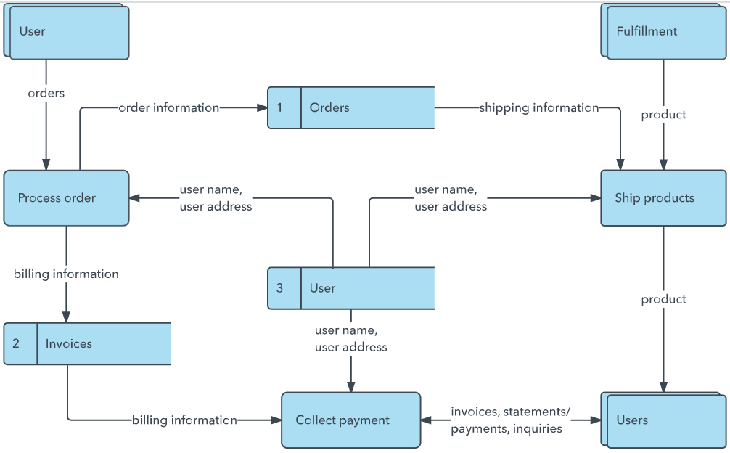


User Stories
Use the below template to list all the user stories for the product.
User Type | Functional Requirement (Epic) | User Story Number | User Story / Task | Acceptance criteria | Priority | Release
Patient | Registration & Auth | USN-1 | As a patient, I can register with my email, password, and phone number so that I can access doctor booking services. | User account created in MongoDB with hashed password and default role 'user' | High | Sprint-1
Patient | Doctor Browsing | USN-2 | As a patient, I can browse approved doctors by specialty, experience, and fees so that I can find a suitable specialist. | Displays grid of approved doctor cards with detailed profiles | High | Sprint-2
Patient | Appointment Booking | USN-3 | As a patient, I can select an appointment date/time and upload medical records so that I can book a consultation. | Booking created in DB with status 'pending' and document stored in uploads/ | High | Sprint-3
Patient | Notifications & History | USN-4 | As a patient, I can view my appointment history and check notifications for status updates. | History table displays appointment status badges; notifications tab lists alerts | Medium | Sprint-4
Doctor | Doctor Application | USN-5 | As a doctor, I can submit my professional details, consultation fees, and working hours for admin review. | Doctor profile created with status 'pending' and notification sent to Admin | High | Sprint-2
Doctor | Appointment Management | USN-6 | As a doctor, I can view appointment requests, download attached patient files, and approve/reject bookings. | Doctor can download file; appointment status updated; patient receives notification | High | Sprint-3
Administrator | Platform Governance | USN-7 | As an admin, I can view all registered users and review doctor applications to approve or reject them. | Admin panel lists users/doctors; clicking Approve/Reject updates status and permissions | High | Sprint-2
Customer Care Executive
Administrator

Data Flow Summary for MediCareBook:
Level 0 DFD (Context Diagram):
- External Entities: Patient, Doctor, Administrator.
- Process: MediCareBook Platform System.
- Data Flows:
* Patient -> Registration Info, Booking Requests, Medical Documents -> MediCareBook
* MediCareBook -> Doctor List, Booking Confirmations, Notifications -> Patient
* Doctor -> Credentials/Timings, Status Updates -> MediCareBook
* MediCareBook -> Assigned Appointments, Patient Documents -> Doctor
* Administrator -> Verification Actions (Approve/Reject) -> MediCareBook
* MediCareBook -> System Reports, Pending Applications -> Administrator
Level 1 DFD (Sub-Processes):
1.0 User Authentication Process
2.0 Doctor Credential Verification Process
3.0 Appointment Scheduling & Document Upload Process
4.0 Notification & Status Update Engine Process

